**TRAINING DATA**

**https://24x7offshoring.com/**

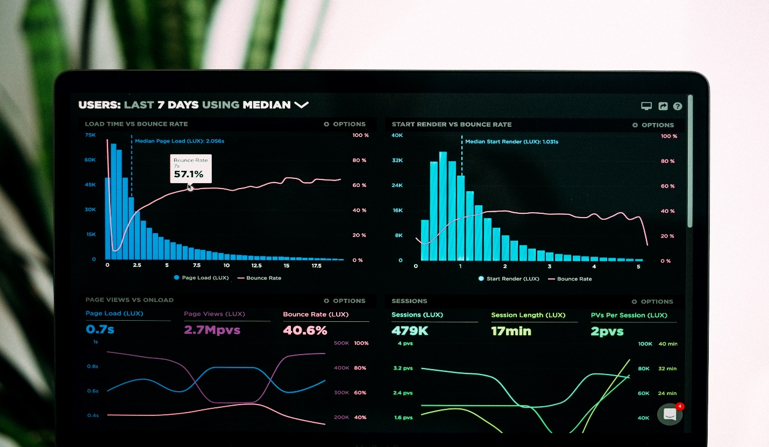[**http://24x7outsourcing.com/**](http://24x7outsourcing.com/)

**What is Training Data?**

Calculations gain from information. They discover connections, create understanding, decide, and assess their certainty from the preparation information they're given. Furthermore, the better the preparation information is, the better the model performs.

Truth be told, the quality and amount of your preparation information has as a lot to do with the achievement of your information project as the actual calculations.

Presently, regardless of whether you've put away a tremendous measure of all around organized information, it probably won't be named in a way that really functions as a preparation dataset for your model.

For instance, independent vehicles don't simply require photos of the street, they need marked pictures where every vehicle, walker, road sign, and more are commented on.

Assessment examination projects require names that assist a calculation with understanding when somebody's utilizing slang or mockery.

Chatbots need element extraction and cautious syntactic investigation, not simply crude language.

As such, the information you need to use for preparing as a rule should be improved or marked. Additionally, you may have to gather a greater amount of it to control your calculations. Odds are, the information you've put away isn't exactly fit to be utilized to prepare AI calculations.

In case you're attempting to make an incredible model, you need a solid establishment, which implies extraordinary preparing information. Also, we know some things about that.

All things considered, we've marked more than 5 billion lines of information for the most inventive organizations on the planet.

Regardless of whether it's pictures, text, sound, or, truly, some other sort of information, we can help make the preparation set that makes your models fruitful.

Study how we can assist you with getting solid preparing information for AI.

**Solid Datasets from 24x7offshoring.com**

Curated from the 24x7offshoring.com stage, we have numerous datasets accessible for the whole information science and AI people group.

The format used to comment on each dataset can be copied so you can extend them on the stage if necessary.

Inside each dataset, you'll track down the crude information, work plan, portrayal, directions, and then some.

**Preparing Data FAQs**

**What is preparing information?**

Neural organizations and other computerized reasoning projects require an underlying arrangement of information, called preparing information, to go about as a pattern for additional application and use.

This information is the establishment for the program's developing library of data.

**What is a test set?**

When a model is prepared on a preparation set, it's normally assessed on a test set.

As a rule, these sets are taken from a similar generally speaking dataset, however the preparation set ought to be named or improved to build a calculation's certainty and precision.

**How might you split up a dataset into test and preparing sets?**

By and large, preparing information is separated pretty much haphazardly, while making a point to catch significant classes you know in advance.

For instance, in case you're attempting to make a model that can peruse receipt pictures from an assortment of stores, you'll need to try not to prepare your calculation on pictures from a solitary establishment.

This will make your model stronger and help keep it from overfitting.

**TRAINING DATA**

**https://24x7offshoring.com/**

**http://24x7outsourcing.com/**